Architectural Overview
The graphic below correspond to an overview of how we can access to the Files that create the CaseMaker,this is a Standalone Application,

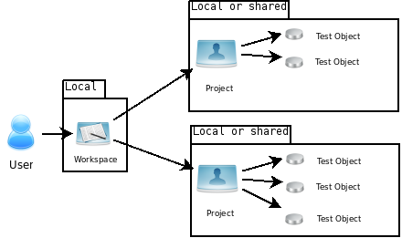

Logical View

Overview
A description of the logical view of the architecture. Describes the most important classes, their organization in service packages and subsystems, and the organization of these subsystems into layers. Also describes the most important use-case realizations, for example, the dynamic aspects of the architecture. Class diagrams are included to illustrate the relationships between architecturally significant classes, subsystems, packages and layers.
The logical view of the CaseMaker is comprised of 2 main packages, and 2 sub packages inside the secod package

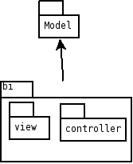

Main View

Model Package
The model package is comprised of all the Objects that represents and stores the logic of the application, most of this classes must be serialized and deserialized at some point.

This package is comprised mostly of two logical groups: Test Cases classes and Test data classes

Test Cases Model
Organizes all elements involved in the test and it’s possible values (Equivalence Classes) and the effects related to each value
The class that holds the reference to all classes of the model is the “Structure”
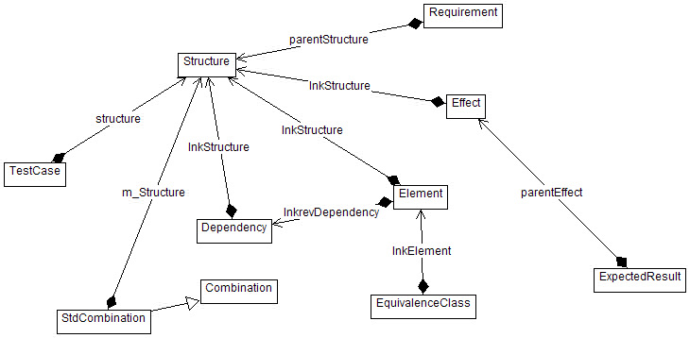

Element
Corresponds to each item or component that will hold different values during the test
Name
Object type (textbox, combo, list ….),
Equivalence Class
Corresponds to each value that the element can have
Name
Value
Risk Level , Status
Effect
Corresponds to each expected outcome after a value or a combination of values are selected
Description
Requirements
Expected Results
Risk Level, Status
Dependency
Represents a relation between the values of two or more elements
Description
Combination
Corresponds to each combination of values from the elements defined in the dependency
Description
Risk Level , Status

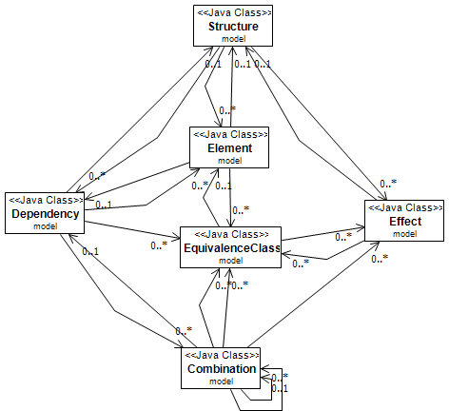

Test Case
Represents the final product of the module and is generated or created from al the equivalence classes and combinations created earlier

Sandart Combination
Is a predefined combination of equivalence classes that can be assigned to many test cases

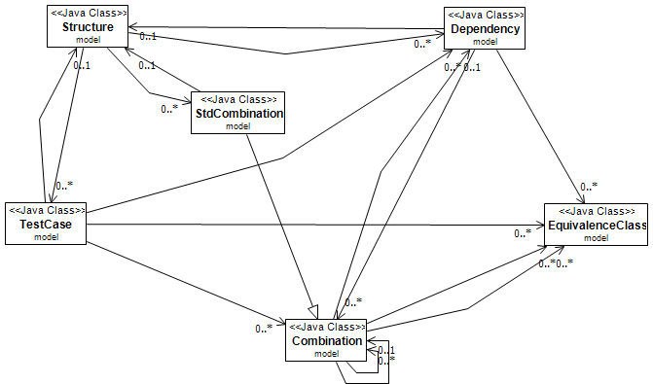

Risk Level and Status
The risk level and status are two attributes found in many of the classes
of the test cases model

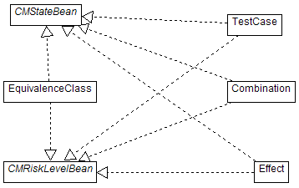

The risk level and status are two attributes found in many of the classes of the test cases model and generates a dependency between the classes related that has these attributes

Test Data Model (Missing SBV)

Undo Redo support
The classes involved in the undo – redo support operations are:
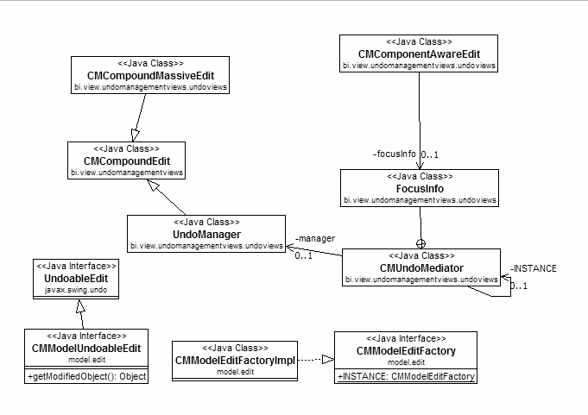
UndoableEdit
is the base interface that mostly all classes implement, two operations are the most important: Undo and Redo and are complemented by the CanUndo and CanRedo operations
CMCompountEdit
This class implements UndoableEdit and can hold several edits to (using the AddEdit method) make a compound undo or redo when necessary. Is used to concatenate operations in sequence
UndoManager
This class represents the queue of all the operations (edits) that the user does
CMComponentAwareEdit
this is a special type of edit that saves the state of the focus on several controls in the screen
CMModelEditFactory
Is the class in charge of creating all the different edits (commands)
Actions
This package represents all actions that the user can execute:
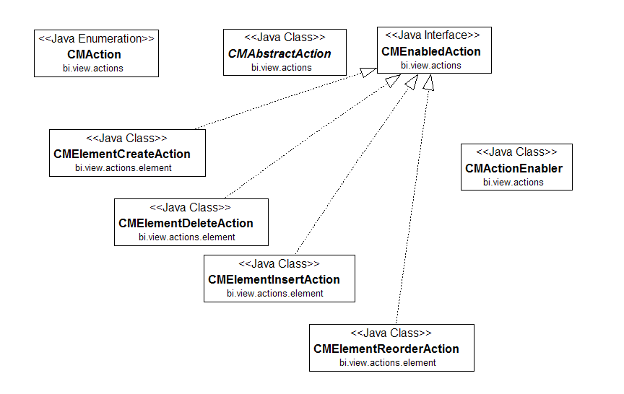

CMAction
this is an Enumeration of all the classes or “Actions” that the user can do also links the action with the interface icon
CMAbstractAction
This is the base class for all the actions of the user interface implements, two operations are the most important here: Execute() and CanExecute()
CMActionEnabler
This class is responsible for enabling and disabling the actions according to the canExecute method (can run on a separate thread)

Reports
The reports in casemaker are generated using xml and xsl-fo, all reports have a Data Source that is a definition of the xml structure. This definition is stored as a XML schema (*.xsd) in the /res folder of the application.
To use this schema it must be compiled using apache's XMLBeans , also all reports have an associated XSL file that contains the transformations needed to generate the desired output
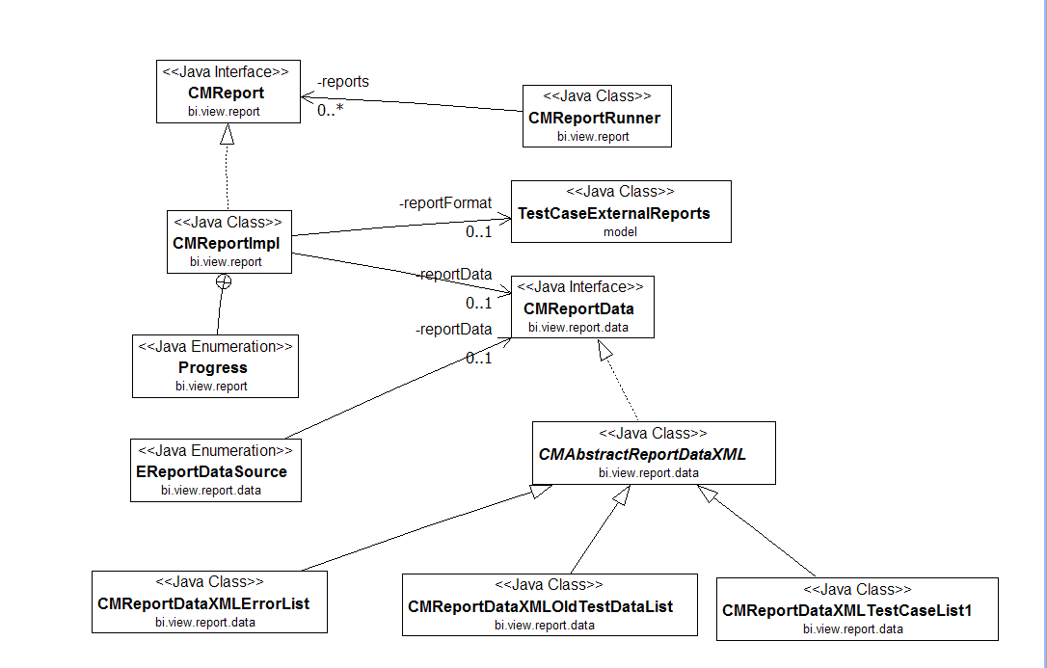
CMReport
This is the base interface for all the reports it has two relationships: a data and a format and a Generate() operation.
CMReportRunner
Responsible for calling the generate method of the report as a separate thread.
CMReportData
This interface represents all the classes that must fill the structure defined in the XSD Schema
TestCaseExternalReports
Represents the associated XSL file of the report
Test Case Generation
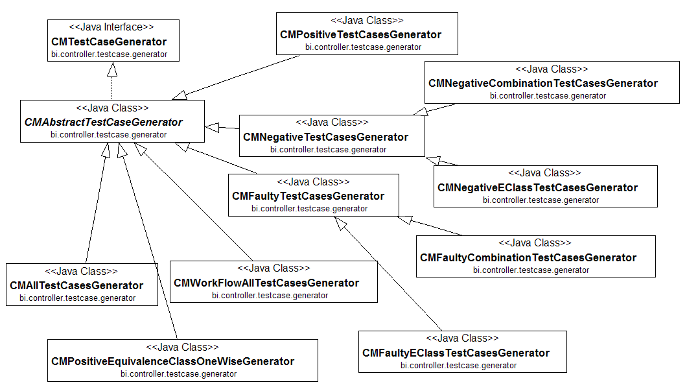
The inheritors of the CMTestCasegenerator interface are the responsible for generating the distinct types of test cases according to the user selection.

Deployment
Casemaker is a standalone application and its deployment configuration is as follows:
